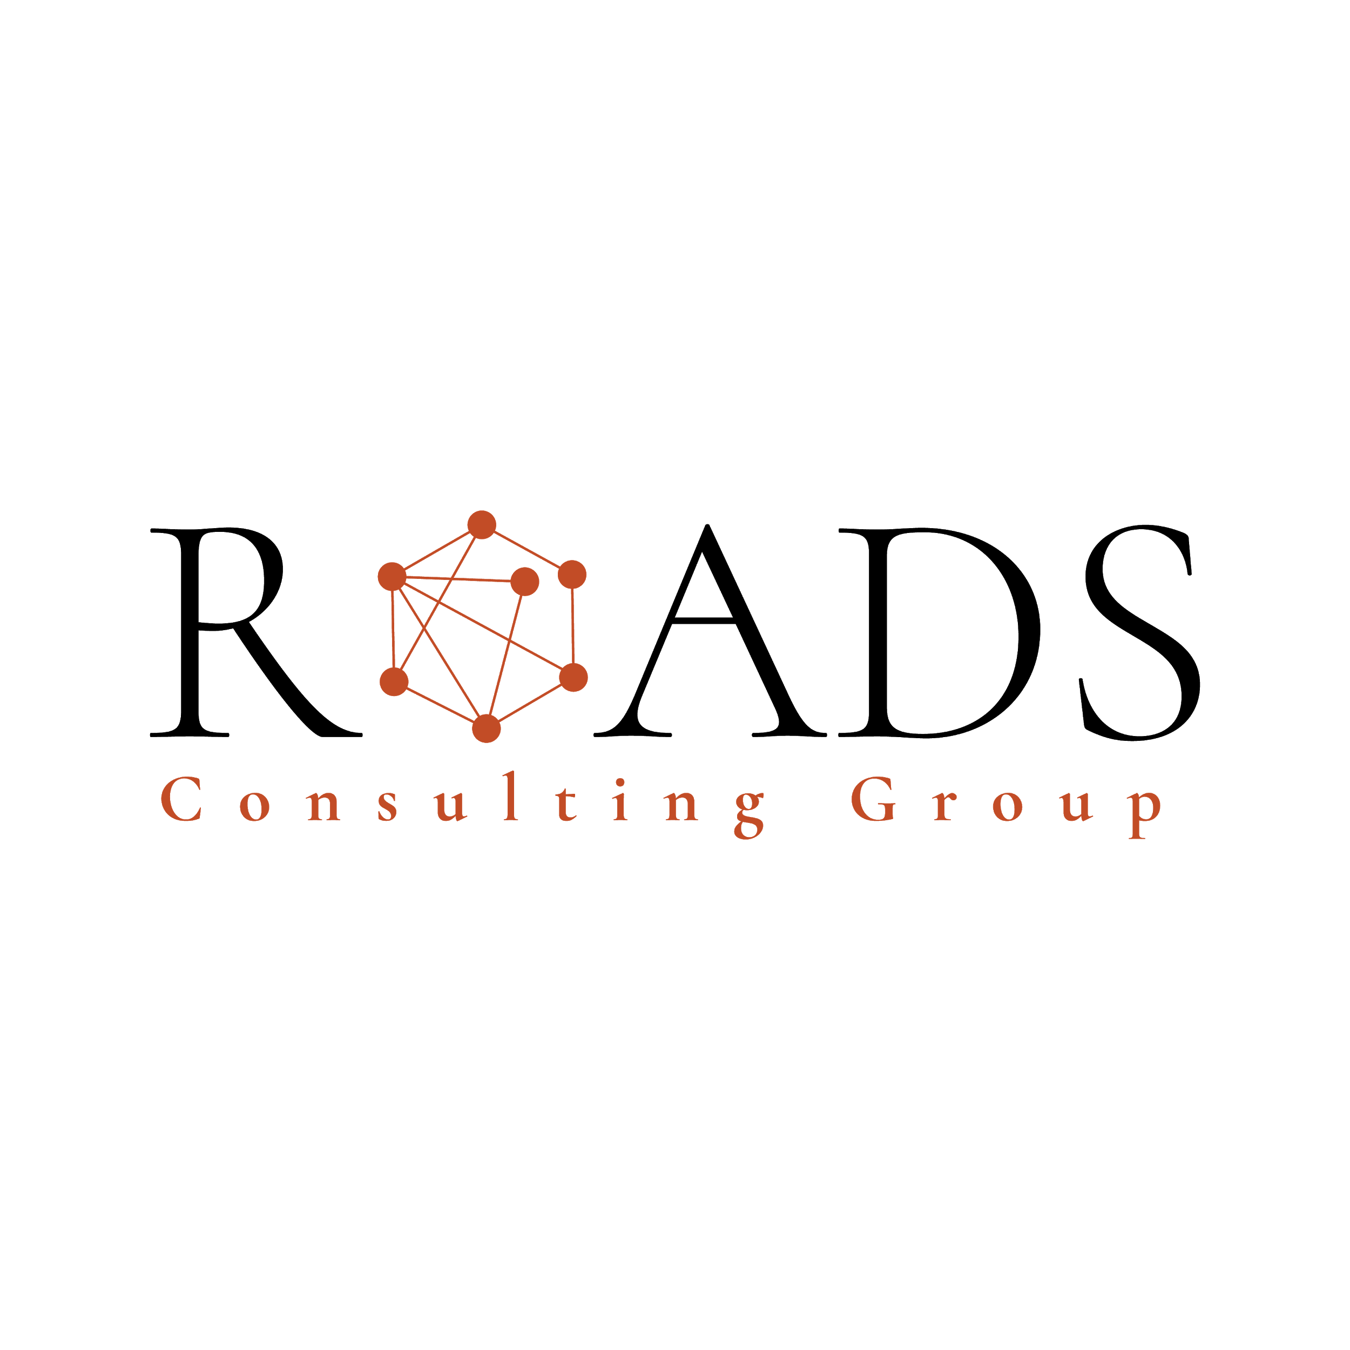 | JOB AND ROLE DESCRIPTION

Position name | Small Business Consultant Manager – Washington State | Company | RCG
Job purpose | We are seeking a dynamic Business Consultant, a highly motivated and experienced professional, to join our team. As a Small Business Consultant/Manager, you will be responsible for overseeing and managing programs aimed at supporting small businesses in collaboration with the Office of economic development. Your primary focus will be providing technical assistance, coordinating with government agencies, and ensuring the smooth operation of various initiatives. The ideal candidate will possess a diverse skill set, including experience working with small businesses, background in finance or accounting, knowledge of government regulations, and excellent communication skills in multiple languages

REQUIRED QUALIFICATIONS
Education
Bachelor's degree in business administration, accounting, economics, or a related field (or equivalent work experience).
Training or Expertise
- Proficiency in Project Management
- Advanced proficiency in Microsoft Suite
- Strong Leadership skills
- Preferred experience in providing seminars and trainings
Experience | 3 or more years of Experience working with small businesses, running programs, dealing with the office of economic development, providing technical assistance, working with government agencies, and being multi-lingual.

JOB FUNCTIONS
- Liaison between government agencies and Roads
- Be the point of contact for the program
- Be the business developer of the program
- Fit leads through the portal
- Assign caseload to roads and manage the deliverables
- Create bi-monthly reports of status
- Attend all client meetings
- Host two seminars per month with entrepreneurs to generate interest in the program
- Follow filtering protocols to ensure compliance
- Create local partnerships with nonprofits and quasi-agencies that do Economic Development
- Convert at least 10% of clients to private clients
- Build partnerships with other counties and municipalities to enlarge the program
- Attend 5 networking opportunities per week
- Create an audience of followers for Road’s social
- Update and grow the database for small businesses
- Growth of the revenue size by 400K years 1, 600K year 2, 1Million year 3
- Look for strategic partners in each sector to give seminars
- Penetrate the Arabic and Asian community
- Find the second employee for this location (1 year)
- Get certified as an MBE in Seattle
- Answer at least 3 RFPs per month
- Manage assistant to achieve sales and program deliverables (not until 6 months)
- Keep an updated online document with cases, networking opportunities, and progress
- Present a weekly report of progress on weekly meeting
- Keep the CRM updated and present a pipeline report at the end of each week
- Attend bi-annual meetings (these are held in Medellin, Colombia)
Program Management:
-Develop, implement, and manage programs designed to support the growth and success of small businesses.
-Collaborate with the Office of economic development to align program goals with the broader economic development strategies of the region.
-Monitor program progress, evaluate outcomes, and make recommendations for improvement.
Technical Assistance:
-Provide direct technical assistance and guidance to small businesses, helping them navigate -challenges and optimize their operations.
-Conduct assessments and identify areas where businesses can improve efficiency, productivity, and profitability.
-Develop and deliver training workshops, seminars, and educational materials to enhance business skills and knowledge.
Government Agency Coordination:
-Serve as the primary liaison between small businesses and various government agencies, ensuring compliance with regulations and requirements.
-Stay up to date with changes in government policies, regulations, and programs relevant to small businesses.
-Facilitate communication and collaboration between small businesses and government entities to address specific needs and concerns.
Multilingual Communication:
-Utilize your linguistic skills to effectively communicate with diverse small business owners and stakeholders who may have limited English proficiency.
-Translate written materials, documents, and resources to assist businesses in accessing information and resources in their preferred language.
-Conduct meetings, workshops, and consultations in multiple languages as needed.

REQUIRED SKILLS
- Advanced proficiency in Microsoft Suite (Word, Excel, PowerPoint, Outlook) for creating and managing professional documents, reports, and presentations.

- Experience with project management software and tools (e.g., Asana, Trello, or similar) for organizing tasks, tracking progress, and collaborating effectively.
-Strong ability to deliver impactful virtual and in-person client presentations using modern tools and technologies

- Mid to High % of travel throughout the State of Washington

-Strong Project Management skills, including the ability to plan, coordinate, and monitor program activities.

-Excellent interpersonal and communication skills, with the ability to engage and build relationships with diverse stakeholders.

-Fluency in multiple languages, with proficiency in written and verbal communication.

-Ability to adapt to changing priorities, work independently, and problem-solve effectively

WAGE COMPENSATION
Base Salary: Between $75K- 85K per year.

Benefits:
-Health Insurance
-Life Insurance
-Dental Insurance
-14 Paid holidays
-5 sick days
-5 Paid Vacation Days
-Gym Membership
-Tele commuting
-401K match
-Yearly Bonuses
-Job Type: Full-time

